

Developer: Michael B. Wood

Date: 04/07/2024

IT 145 Global Rain Summary Report Template

Directions
Place your pseudocode, flowchart, and explanation in the following sections. Before you submit your report, remove all bracketed text.

Pseudocode
When you are done implementing the Pet class, refer back to the Pet BAG Specification Document and select either the pet check in or check out method. These methods are detailed in the Functionality section of the specification document.

Write pseudocode that lays out a plan for the method you chose, ensuring that you organize each step in a logical manner. Remember, you will not be creating the actual code for the method. You do not have to write pseudocode for both methods. Your pseudocode must not exceed one page.

- Start
- Input Pet Type
- Space Available
- Input Pet
- New or Pre-Existing Pet
- Add or Update Pet Info
- Length of Stay if More than 2 Days Ask About Grooming
- If Less than 2 Days Assign Space
- If More than 2 Days ask about Grooming
- Add Grooming Info if Wanted Service
- Assign Space
- End

Flowchart
Based on the pseudocode you wrote, create a flowchart using a tool of your choice for the method you selected. In your flowchart, be sure to include start and end points and appropriate decision branching, and align the flowchart to the check in or check out process. Your flowchart must be confined to one page.
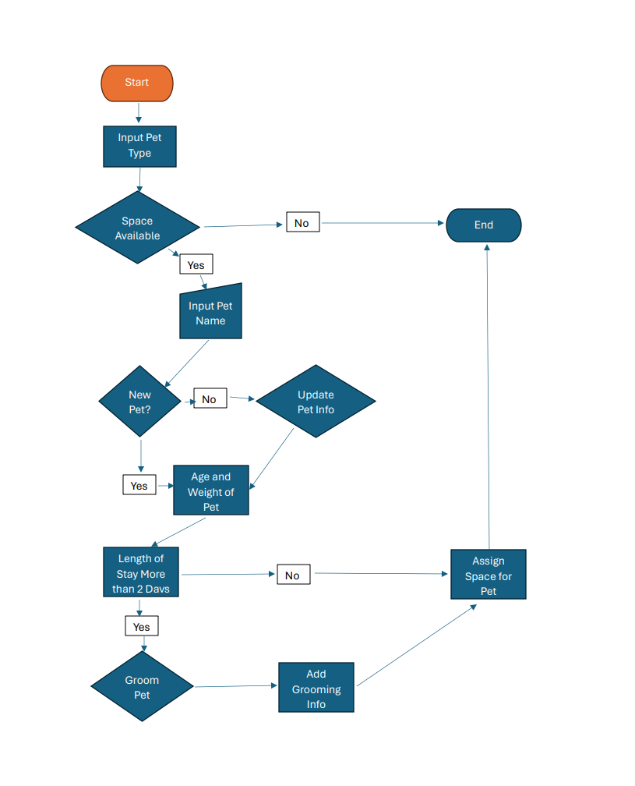

OOP Principles Explanation
Briefly explain how you applied object-oriented programming principles and concepts (such as encapsulation, inheritance, and so on) in your software development work thus far. Your explanation should be one paragraph, or four to six sentences.

To make our codebase more transparent, easier to maintain, and more extensible, we have strictly adhered to object-oriented programming (OOP) concepts throughout our software development process. A fundamental principle is encapsulation, which allows for ordered and modular code by enclosing related data and functions into classes. With the use of inheritance, we can now establish hierarchical connections between classes, which facilitates code reuse and reduces repetition. By making use of polymorphism, systems can be made more adaptable and versatile, with objects being able to display varied behaviors according to their type. To further promote high cohesion and low dependency between components, we have prioritized abstraction to highlight important traits while hiding implementation specifics.

